Module Assembly - TopCoder NodeJS Submit Design Challenge Submission API Update Deployment Guide

Revision History
Author | Revision Number | Date
isv | 1.0 | 05/09/2014

Deployment Instructions 3
1. Organization of Submission 3
2. Application Setup 3
2.1 Configuration 3
2.2 Build Scripts Setup 4
3. Database Setup 4
4. Deployment Instructions 4
5. Starting 5
6. Verification 5
7. Resource Contact List 7

Deployment Instructions

Organization of Submission

The submission follows directory structure provided below:

docs

Contains this document which is the Deployment Guide for the Module Assembly - TopCoder NodeJS Submit Design Challenge Submission API Update assembly.

tc-api

Contains the configuration, libraries, sources for TopCoder Node JS API application developed/updated in the course of this assembly. This directory replicates the application development distribution structure and includes only updated and new files.

Application Setup

The submission is expected to be deployed to the following environment:

JRE 1.7
NodeJS 0.10.21
Informix DS 11.0
Git

This assembly was developed against following Git commit hash:

URL: https://github.com/cloudspokes/tc-api.git
Hash: e27a7dd5c2dcbec378467c843b05c4a7d27418d4

Configuration

Following new configuration parameters have been defined by previous assemblies integrated by this assembly:

Property Name | File property is stored | Example Setting
config.watermark.filePath | tc-api/config.js | A path to watermark image. The actual value may be set by WATERMARK_FILE_PATH environment variable.
config.watermark.fileType | tc-api/config.js | A type to watermark image. Defaults to PNG. The actual value may be set by WATERMARK_FILE_TYPE environment variable.
config.watermark. baseImageTransparency | tc-api/config.js | A base image transparency for watermark image. Defaults to 50. The actual value may be set by WATERMARK_BASE_IMAGE_TRANSPARENCY environment variable.
config.watermark. overlayImageTransparency | tc-api/config.js | An overlay image transparency for watermark image. Defaults to 100. The actual value may be set by WATERMARK_OVERLAY_IMAGE_TRANSPARENCY environment variable.
config.watermark.overlayImageRed | tc-api/config.js | Overlay image red color weight for watermark image. Defaults to 0. The actual value may be set by WATERMARK_OVERLAY_IMAGE_RED environment variable.
config.watermark. overlayImageGreen | tc-api/config.js | Overlay image green color weight for watermark image. Defaults to 0. The actual value may be set by WATERMARK_OVERLAY_IMAGE_GREEN environment variable.
config.watermark. overlayImageBlue | tc-api/config.js | Overlay image blue color weight for watermark image. Defaults to 0. The actual value may be set by WATERMARK_OVERLAY_IMAGE_BLUE environment variable.
config. galleryIds | tc-api/config.js | An array listing the IDs for challenge categories which require preview galleries to be generated.
config.jvm.minMemory | tc-api/config.js | Minimum memory to be allocated by JVM (like 128m)
config.jvm.maxMemory | tc-api/config.js | Maximum memory to be allocated by JVM (like 512m)
designSubmission.sourcePrefix | tc-api/config.js | A prefix for entries in submission archive corresponding to native source files (for example, source/)
designSubmission.submissionPrefix | tc-api/config.js | A prefix for entries in submission archive corresponding to submission and preview files (for example, submission/)

Build Scripts Setup

The TopCoder NodeJS API application provides the following commands which are to be used:

- npm install – installs TopCoder NodeJS API application
- npm rebuild – rebuilds TopCoder NodeJS API application
- npm test – runs Mocha-based unit tests.

Database Setup

No changes to existing database schema have been introduced with this assembly.

Deployment Instructions

- Set up necessary infrastructure for TopCoder NodeJS API based on your environment See following page for details (click the link corresponding to your OS):
  - https://github.com/cloudspokes/tc-api/wiki/_pages
- Clone TopCoder NodeJS application from Git repository https://github.com/cloudspokes/tc-api.git to your local machine. See chapters suitable for your local environment at following page for details (click the link corresponding to your OS):
  - https://github.com/cloudspokes/tc-api/wiki/_pages
- Checkout the TopCoder NodeJS application commit referenced by hash specified by section 2 of this guide
- Copy the code from tc-api directory of this submission into working copy cloned from Git repository at step above
- Set up environment variables to suit the current environment. See https://github.com/cloudspokes/tc-api/wiki/Configure-Environment-Variables In particular setting designSubmissionsBasePath and designSubmissionTmpPath in tc-api/config.js file is important. Also config.watermark.filePath property must point to an existing file to be used for watermarking the generated images.
- Install TopCoder NodeJS API application using npm install command. See chapters suitable for your local environment at https://github.com/cloudspokes/tc-api/wiki/_pages for help (click the link corresponding to your OS)

Starting

- Install the TopCoder NodeJS API application
- Start ActionsHero server instance hosting TopCoder NodeJS API application (see Start Server chapter at page matching your current OS at https://github.com/cloudspokes/tc-api/wiki/_pages)

Verification

- Setup node-jslint tool using command like npm install jslint -g and check formatting for the updated code using commands like:

jslint --nomen common/designImageFileGenerator.js
jslint --nomen common/unifiedSubmissionValidator.js
jslint --nomen actions/designImageFileGeneratorTest.js
jslint --nomen actions/unifiedSubmissionValidatorTest.js
jslint --nomen test/test.unifiedSubmissionValidator.js
jslint --nomen test/test.submitDesignChallenge.js
jslint --nomen routes.js
jslint --nomen config.js
jslint --nomen actions/challenges.js

There must be no code formatting errors displayed:

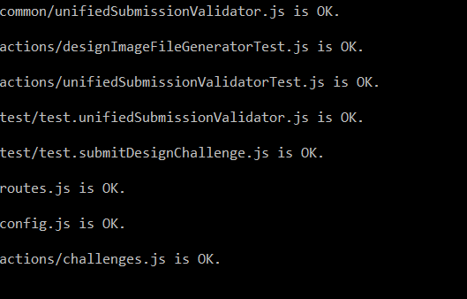

- Run the unit tests using command like:

node_modules/.bin/mocha ./test/test.submitDesignChallenge.js
node_modules/.bin/mocha ./test/test.unifiedSubmissionValidator.js

The tests must be executed successfully:

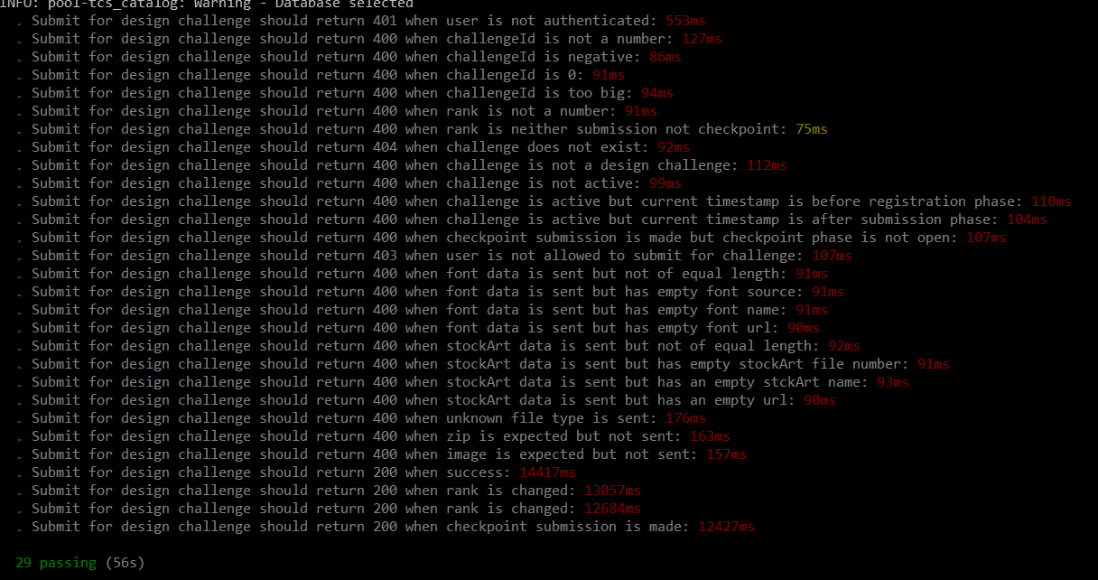

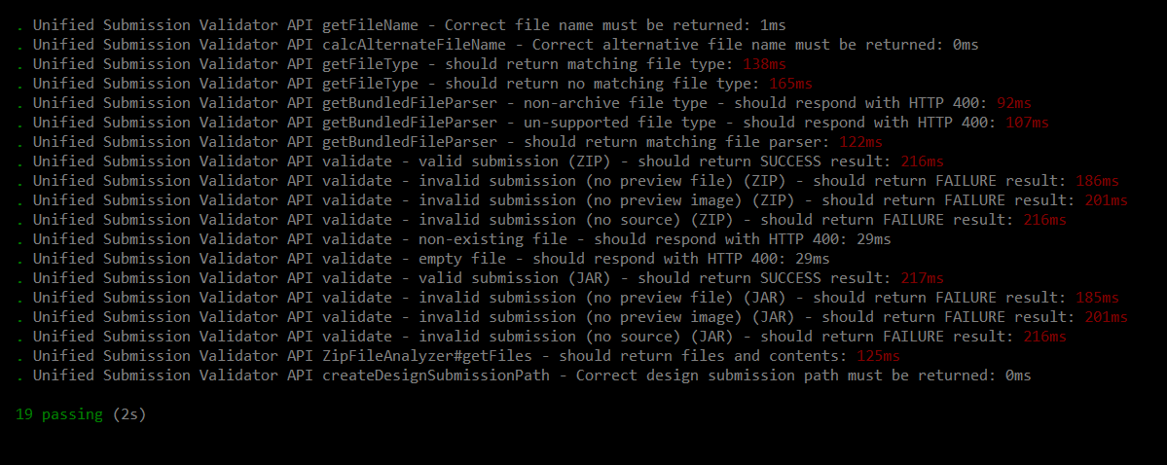

Resource Contact List

Name | Resource Email
isv

